Karnatak Law Society’s

GOGTE INSTITUTE OF TECHNOLOGY

Udyambag Belagavi -590008

Karnataka, India.



A Course Project Report on

**Travel Agency Website**

Submitted for the requirements of 3rd semester B.E. in CSE

for **“Web Programming (Integrated)”**

**Submitted by**

|  |  |
| --- | --- |
| **NAME** | **USN** |
| **Sanket Patil** | **2GI20CS132** |
| **Shradha M Patil** | **2GI20CS144** |
| **Srushti B Mudennavar** | **2GI20CS158** |
| **Vijayalaxmi S Korti** | **2GI20CS178** |

**Under the guidance of**

**Prof. Veena Kangralkar**

**Asst. Prof., Dept. of CSE**

Karnatak Law Society’s

GOGTE INSTITUTE OF TECHNOLOGY

Udyambag Belagavi -590008

Karnataka, India.

**Department of Computer Science and Engineering**



Certificate

**Academic Year 2021-2022 (Odd semester)**

This is to certify that the Course project titled **“Travel Agency Website”** for **“Web Programming (18CSL36)”** carried out by students SANKET PATIL(2GI20CS132), SHRADHA MALLIKARJUN PATIL(2GI20CS144), SRUSHTI B MUDENNAVAR(2GI20CS158), VIJAYALAXMI S KORTI(2GI20CS178) is submitted in partial fulfilment of the requirements for 3 rd semester B.E. in COMPUTER SCIENCE AND ENGINEERING, Visvesvaraya Technological University, Belagavi. It is certified that all corrections/ suggestions indicated have been incorporated in the report. The course project report has been approved as it satisfies the academic requirements prescribed for the said degree.

Date:25-01-2022 Signature of Guide

Place: Belagavi Prof. Veena Kangralkar

Asst. Prof., Dept. of CSE

KLS Gogte Institute of Technology

**Project Evaluation Sheet**

1. Title

2. Problem statement for that the project

3. Objectives of Defined Problem statement

4. Design / Algorithm/Flowchart/Methodology

5. Implementation details/Function/Procedures/Classes and Objects (Language/Tools)

6. Working model of the final solution

7. Report and Oral Presentation skill

**Marks allocation:**

|  |  |  |  |  |  |  |
| --- | --- | --- | --- | --- | --- | --- |
|  | Batch No. : | | | | | |
| 1. | Project Title: Travel Agency Website | Marks Range | USN | | | |
| 2GI20CS132 | 2GI20CS144 | 2GI20CS158 | 2GI20CS178 |
| 2. | Problem statement (PO2) | 0-1 |  |  |  |  |
| 3. | Objectives of Defined Problem statement (PO1,PO2) | 0-2 |  |  |  |  |
| 4. | Design / Algorithm/Flowchart/Methodology (PO3) | 0-3 |  |  |  |  |
| 5. | Implementation details/Function/Procedures/Classes and Objects (Language/Tools) (PO1,PO3,PO4,PO5) | 0-4 |  |  |  |  |
| 6. | Working model of the final solution (PO3,PO12) | 0-5 |  |  |  |  |
| 7. | Report and Oral presentation skill (PO9,PO10) | 0-5 |  |  |  |  |
|  | Total | 20 |  |  |  |  |

**\* 20 marks is converted to 10 marks for CGPA calculation.**

Contents:

|  |  |  |
| --- | --- | --- |
| Sl. No. | Topic | Page no. |
| 1. | Abstract | 5 |
| 2. | Introduction | 6 |
| 3. | Theory and Objectives | 6 |
| 4. | Software Used | 7 |
| 5. | Source Code | 7 |
| 6. | Output Screenshots | 36 |
| 7. | Conclusion | 39 |
| 8. | Reference | 39 |

Abstract:

Gone are the days when people used to stand in long queues for ticket booking and other travel related reservation. In today’s world of computers everything is done online . Online Booking and Reservation System is a very fast moving area. So to go hand in hand with the latest technologies, we have developed a completely Online booking and reservation website. From Booking your next holiday with Family to planning Himalayan treks with your friends, we have it all. It helps to manage bookings. This will provide better opportunities and guidance for future in developing projects independently.

Need for a Website:

The most significant advantage of a travel website is that it gives you a chance to present tour packages and sell them from your own platform.

Due to an easy-to-manage website, you can post, manage, and publish tour packages. With the help of an [SEO-optimized website](https://aist.global/en/importance-of-small-businesses-seo-services), you reach a wider audience and introduce your packages to a wider market. The more is the number of your visitors; the bigger is the percentage of sales.

Imagine you have a website for your tour and travel services. You

**✔** are trustworthy,

**✔** manage bookings easily,  
**✔** attract people with your engaging content,  
**✔** help travellers find their perfect choice with the least possible efforts,  
**✔** are available.

Introduction:

As an example, this website has primary goal : To help people become better tours and travel packages. The website provides good graphic design that makes the articles easy to read. It is mobile friendly. It has a good SEO (Search Engine Optimization) so that people find the articles through Google and other search engines. It also has a gallery and review section. Through this Website we can publish high quality articles that over time become a useful resource for people who love travelling. The clients can also easily navigate so that people can easily find the packages and photos of the relevant places in gallery section. Graphical User Interface are developed using HTML5, CSS, JavaScript, jQuery and Bootstrap to provide an easy-to-understand interactive screens.

Theory and Objectives

We have divided our project into 3 parts-

* Navigation Bar
* Body (home, about us, featured locations, gallery, contact us)
* Footer

We have used concepts like HTML, CSS, JavaScript ,Bootstrap etc.

The main objective of this project is to learn how to build a web application using html, css, javascript etc. We have created a tours and travels website which has various sections as mentioned above which will help the users to easily navigate and also find photos related to specific locations in gallery section. Thus using the above mentioned concepts, we have made a front-end design of a tours and travels webpage.

Software Used:

Software Requirements:

* + - Operating System: Windows 10/7
    - IDE:Atom, Visual Studio Code
    - Front End: HTML5, CSS3, JavaScript, jQuery.
    - Browser: Chrome or Firefox or Internet Explorer

Source Code:

HTML Code:

<!DOCTYPE html>

<html lang="en">

<head>

<meta charset=" UTF-8 ">

<meta name=" viewport " content="width=device-width,initial-scale=1.0 ">

<title>Travel Agency Website </title>

<!--font awesome cdn link-->

<link rel="stylesheet " href="https://cdnjs.cloudflare.com/ajax/libs/font-awesome/5.15.4/css/all.min.css ">

<!--custom css file link-->

<link rel="stylesheet " href="D:\Srushti\GIT\3rd sem\project\web\travel.css">

</head>

<body>

<!-- header section starts-->

<header>

<div id="menu-bar" class="fas fa-bars"></div>

<a href="#" class="logo"><span>T</span>ravel</a>

<nav class="navbar">

<a href="#home">home</a>

<a href="#book">book</a>

<a href="#packages">packages</a>

<a href="#services">services</a>

<a href="#gallery">gallery</a>

<a href="#review">review</a>

<a href="#contact">contact</a>

</nav>

<div class="icons">

<i class="fas fa-search" id="search-btn"></i>

<i class="fas fa-user" id="login-btn"></i>

</div>

<form action="" class="search-bar-container">

<input type="search"id="search-bar" placeholder="search here...">

<label for="search-bar" class="fas fa-search"></label>

</form>

</header>

<!-- header section starts-->

<!--login form container-->

<div class="login-form-container">

<i class="fas fa-times" id="form-close"></i>

<form action="">

<h3>login</h3>

<input type="email" class="box" placeholder="enter your email">

<input type="password" class="box" placeholder="enter your password">

<input type="submit" value="login now" class="btn">

<input type="checkbox" id="remember">

<label for="remember">remember me</label>

<p>forgot password? <a href="#">click here</a></p>

<p>Don't have an account? <a href="#">register now</a></p>

</form>

</div>

<!--home section starts-->

<section class="home" id="home">

<div class="content ">

<h3>adventure is worthwhile</h3>

<p>discover new places with us,adventure awaits</p>

<a href="# " class="btn">discover more</a>

</div>

<div class="controls">

<span class="vid-btn active"data-src="D:\Srushti\GIT\3rd sem\project\web\Skyscrapers - 80724.mp4"></span>

<span class="vid-btn"data-src="D:\Srushti\GIT\3rd sem\project\web\Waves - 70796.mp4"></span>

<span class="vid-btn"data-src="D:\Srushti\GIT\3rd sem\project\web\Ocean - 19609.mp4"></span>

<span class="vid-btn"data-src="D:\Srushti\GIT\3rd sem\project\web\Mountains - 59291.mp4"></span>

<span class="vid-btn"data-src="D:\Srushti\GIT\3rd sem\project\web\Bike - 72566.mp4"></span>

</div>

<div class="video-container">

<video src="D:\Srushti\GIT\3rd sem\project\web\Skyscrapers - 80724.mp4" id="video-slider" loop autoplay muted></video>

</div>

</section>

<!--home section ends-->

<!--book section starts-->

<section class="book" id="book">

<h1 class="heading">

<span>b</span>

<span>o</span>

<span>o</span>

<span>k</span>

<span class="space"></span>

<span>n</span>

<span>o</span>

<span>w</span>

</h1>

<div class="row">

<div class="image">

<img src="D:\Srushti\GIT\3rd sem\project\web\istockphoto-1318138963-612x612.jpg"alt="">

</div>

<form action="">

<div class="inputBox">

<h3>Where to</h3>

<input type="text" placeholder="Place name">

</div>

<div class="inputBox">

<h3>How many</h3>

<input type="number" placeholder="Number of guests">

</div>

<div class="inputBox">

<h3>Arrivals</h3>

<input type="date">

</div>

<div class="inputBox">

<h3>Leaving</h3>

<input type="date">

</div>

<input type="submit" class="btn" value="book now">

</form>

</div>

</section>

<!--book section ends-->

<!--Packages section-->

<section class="packages" id="packages">

<h1 class="heading">

<span>p</span>

<span>a</span>

<span>c</span>

<span>k</span>

<span>a</span>

<span>g</span>

<span>e</span>

<span>s</span>

<span class="space"></span>

</h1>

<div class="box-container">

<div class="box">

<img src="D:\Srushti\GIT\3rd sem\project\web\demo\paris.jpg">

<div class="content">

<h3><i class="fas fa-map-marker-alt"></i>paris</h3>

<p>Paris is arguably Europe’s most Instagrammable city.</p>

<div class="stars">

<i class="fas fa-star"></i>

<i class="fas fa-star"></i>

<i class="fas fa-star"></i>

<i class="fas fa-star"></i>

<i class="fas fa-star"></i>

</div>

<div class="price"> $90.00 <span>$120.00</span></div>

<a href="#" class="btn">Book Now</a>

</div>

</div>

<div class="box">

<img src="D:\Srushti\GIT\3rd sem\project\web\demo\seoul.jpg">

<div class="content">

<h3><i class="fas fa-map-marker-alt"></i>Seoul</h3>

<p>Seoul combines ancient history with ultra-modern design and technology. </p>

<div class="stars">

<i class="fas fa-star"></i>

<i class="fas fa-star"></i>

<i class="fas fa-star"></i>

<i class="fas fa-star"></i>

<i class="fas fa-star"></i>

</div>

<div class="price"> $90.00 <span>$120.00</span></div>

<a href="#" class="btn">Book Now</a>

</div>

</div>

<div class="box">

<img src="D:\Srushti\GIT\3rd sem\project\web\demo\bali.jpg">

<div class="content">

<h3><i class="fas fa-map-marker-alt"></i>Bali</h3>

<p>Bali is one of the most evocative islands of the entire Indonesian archipelago.</p>

<div class="stars">

<i class="fas fa-star"></i>

<i class="fas fa-star"></i>

<i class="fas fa-star"></i>

<i class="fas fa-star"></i>

<i class="fas fa-star"></i>

</div>

<div class="price"> $90.00 <span>$120.00</span></div>

<a href="#" class="btn">Book Now</a>

</div>

</div>

<div class="box">

<img src="D:\Srushti\GIT\3rd sem\project\web\demo\jordan.jpg">

<div class="content">

<h3><i class="fas fa-map-marker-alt"></i>Jordan</h3>

<p>Jordan, a traveler's dream introduction to the Middle East.</p>

<div class="stars">

<i class="fas fa-star"></i>

<i class="fas fa-star"></i>

<i class="fas fa-star"></i>

<i class="fas fa-star"></i>

<i class="fas fa-star"></i>

</div>

<div class="price"> $90.00 <span>$120.00</span></div>

<a href="#" class="btn">Book Now</a>

</div>

</div>

<div class="box">

<img src="D:\Srushti\GIT\3rd sem\project\web\demo\sydney.jpg">

<div class="content">

<h3><i class="fas fa-map-marker-alt"></i>Sydney</h3>

<p>Sydney the oldest, biggest, and most beautiful of all Australian cities.</p>

<div class="stars">

<i class="fas fa-star"></i>

<i class="fas fa-star"></i>

<i class="fas fa-star"></i>

<i class="fas fa-star"></i>

<i class="fas fa-star"></i>

</div>

<div class="price"> $90.00 <span>$120.00</span></div>

<a href="#" class="btn">Book Now</a>

</div>

</div>

<div class="box">

<img src="D:\Srushti\GIT\3rd sem\project\web\demo\vancouver.jpg">

<div class="content">

<h3><i class="fas fa-map-marker-alt"></i>Vancouver</h3>

<p>With its extensive parks , Vancouver is a paradise for outdoor activities.</p>

<div class="stars">

<i class="fas fa-star"></i>

<i class="fas fa-star"></i>

<i class="fas fa-star"></i>

<i class="fas fa-star"></i>

<i class="fas fa-star"></i>

</div>

<div class="price"> $90.00 <span>$120.00</span></div>

<a href="#" class="btn">Book Now</a>

</div>

</div>

<div class="box">

<img src="D:\Srushti\GIT\3rd sem\project\web\demo\vegas.jpg">

<div class="content">

<h3><i class="fas fa-map-marker-alt"></i>Las Vegas</h3>

<p>This city in the desert is known around the world for fun and excitement.</p>

<div class="stars">

<i class="fas fa-star"></i>

<i class="fas fa-star"></i>

<i class="fas fa-star"></i>

<i class="fas fa-star"></i>

<i class="fas fa-star"></i>

</div>

<div class="price"> $90.00 <span>$120.00</span></div>

<a href="#" class="btn">Book Now</a>

</div>

</div>

</div>

</section>

<!--Packages section ends -->

<!--Services section-->

<section class="services" id="services">

<h1 class="heading">

<span>s</span>

<span>e</span>

<span>r</span>

<span>v</span>

<span>i</span>

<span>c</span>

<span>e</span>

<span>s</span>

<span class="space"></span>

</h1>

<div class="box-container">

<div class="box">

<i class="fa fa-hotel"></i>

<h3>Affordable Hotels </h3>

<p>Lorem ipsum dolor sit amet, consectetur adipiscing elit, sed do eiusmod tempor incididunt ut labore et dolore magna aliqua. </p>

</div>

<div class="box">

<i class="fa fa-utensils"></i>

<h3>Food and Drinks </h3>

<p>Lorem ipsum dolor sit amet, consectetur adipiscing elit, sed do eiusmod tempor incididunt ut labore et dolore magna aliqua. </p>

</div>

<div class="box">

<i class="fa fa-bullhorn"></i>

<h3>Safety Guide </h3>

<p>Lorem ipsum dolor sit amet, consectetur adipiscing elit, sed do eiusmod tempor incididunt ut labore et dolore magna aliqua. </p>

</div>

<div class="box">

<i class="fa fa-globe-asia"></i>

<h3>Around The World </h3>

<p>Lorem ipsum dolor sit amet, consectetur adipiscing elit, sed do eiusmod tempor incididunt ut labore et dolore magna aliqua. </p>

</div> <div class="box">

<i class="fa fa-plane"></i>

<h3>Fastest travel </h3>

<p>Lorem ipsum dolor sit amet, consectetur adipiscing elit, sed do eiusmod tempor incididunt ut labore et dolore magna aliqua. </p>

</div>

<div class="box">

<i class="fa fa-hiking"></i>

<h3>Adventures </h3>

<p>Lorem ipsum dolor sit amet, consectetur adipiscing elit, sed do eiusmod tempor incididunt ut labore et dolore magna aliqua. </p>

</div>

</div>

</section>

<!--Services section ends here -->

<!--gallery section-->

<section class="gallery" id="gallery">

<h1 class="heading">

<span>g</span>

<span>a</span>

<span>l</span>

<span>l</span>

<span>e</span>

<span>r</span>

<span>y</span>

</h1>

<div class="box-container">

<div class="box">

<img src="D:\Srushti\GIT\3rd sem\project\web\demo\kashmir.jpg" alt="">

<div class="content">

<h3> Amazing Places </h3>

<p>Lorem ipsum dolor sit amet, consectetur adipiscing elit, sed do eiusmod tempor incididunt ut labore et dolore magna aliqua.</p>

<a href="#" class="btn">See More</a>

</div>

</div>

<div class="box">

<img src="D:\Srushti\GIT\3rd sem\project\web\demo\rajasthan.jpg" alt="">

<div class="content">

<h3> Amazing Places </h3>

<p>Lorem ipsum dolor sit amet, consectetur adipiscing elit, sed do eiusmod tempor incididunt ut labore et dolore magna aliqua.</p>

<a href="#" class="btn">See More</a>

</div>

</div>

<div class="box">

<img src="D:\Srushti\GIT\3rd sem\project\web\demo\london.jpg" alt="">

<div class="content">

<h3> Amazing Places </h3>

<p>Lorem ipsum dolor sit amet, consectetur adipiscing elit, sed do eiusmod tempor incididunt ut labore et dolore magna aliqua.</p>

<a href="#" class="btn">See More</a>

</div>

</div>

<div class="box">

<img src="D:\Srushti\GIT\3rd sem\project\web\demo\sf.jpg" alt="">

<div class="content">

<h3> Amazing Places </h3>

<p>Lorem ipsum dolor sit amet, consectetur adipiscing elit, sed do eiusmod tempor incididunt ut labore et dolore magna aliqua.</p>

<a href="#" class="btn">See More</a>

</div>

</div>

<div class="box">

<img src="D:\Srushti\GIT\3rd sem\project\web\demo\sahara.jpg" alt="">

<div class="content">

<h3> Amazing Places </h3>

<p>Lorem ipsum dolor sit amet, consectetur adipiscing elit, sed do eiusmod tempor incididunt ut labore et dolore magna aliqua.</p>

<a href="#" class="btn">See More</a>

</div>

</div>

<div class="box">

<img src="D:\Srushti\GIT\3rd sem\project\web\demo\thailand.jpg" alt="">

<div class="content">

<h3> Amazing Places </h3>

<p>Lorem ipsum dolor sit amet, consectetur adipiscing elit, sed do eiusmod tempor incididunt ut labore et dolore magna aliqua.</p>

<a href="#" class="btn">See More</a>

</div>

</div>

<div class="box">

<img src="D:\Srushti\GIT\3rd sem\project\web\demo\santorini.jpg" alt="">

<div class="content">

<h3> Amazing Places </h3>

<p>Lorem ipsum dolor sit amet, consectetur adipiscing elit, sed do eiusmod tempor incididunt ut labore et dolore magna aliqua.</p>

<a href="#" class="btn">See More</a>

</div>

</div>

<div class="box">

<img src="D:\Srushti\GIT\3rd sem\project\web\demo\egypt.jpg" alt="">

<div class="content">

<h3> Amazing Places </h3>

<p>Lorem ipsum dolor sit amet, consectetur adipiscing elit, sed do eiusmod tempor incididunt ut labore et dolore magna aliqua.</p>

<a href="#" class="btn">See More</a>

</div>

</div>

<div class="box">

<img src="D:\Srushti\GIT\3rd sem\project\web\demo\maldives.jpg" alt="">

<div class="content">

<h3> Amazing Places </h3>

<p>Lorem ipsum dolor sit amet, consectetur adipiscing elit, sed do eiusmod tempor incididunt ut labore et dolore magna aliqua.</p>

<a href="#" class="btn">See More</a>

</div>

</div>

<div class="box">

<img src="D:\Srushti\GIT\3rd sem\project\web\demo\istanbul.jpg" alt="">

<div class="content">

<h3> Amazing Places </h3>

<p>Lorem ipsum dolor sit amet, consectetur adipiscing elit, sed do eiusmod tempor incididunt ut labore et dolore magna aliqua.</p>

<a href="#" class="btn">See More</a>

</div>

</div>

</div>

</section>

<!--gallery section ends here-->

<!--review section-->

<section class="review" id="review">

<h1 class="heading">

<span>r</span>

<span>e</span>

<span>v</span>

<span>i</span>

<span>e</span>

<span>w</span>

</h1>

<div class="swiper-container review-slider">

<div class="swiper-wrapper">

<div class="swiper-slide">

<div class="box">

<img src="D:\Srushti\GIT\3rd sem\project\web\demo\p1.jpg" alt="">

<h3>John Deo</h3>

<p>Lorem ipsum dolor sit amet, consectetur adipiscing elit, sed do eiusmod tempor incididunt ut labore et dolore magna aliqua. Ut enim ad minim veniam, quis nostrud exercitation ullamco laboris nisi ut aliquip ex ea commodo consequat. </p>

<div class="stars">

<i class="fas fa-star"></i>

<i class="fas fa-star"></i>

<i class="fas fa-star"></i>

<i class="fas fa-star"></i>

<i class="fas fa-star"></i>

</div>

</div>

</div>

<div class="swiper-slide">

<div class="box">

<img src="D:\Srushti\GIT\3rd sem\project\web\demo\p2.jpg" alt="">

<h3>John Deo</h3>

<p>Lorem ipsum dolor sit amet, consectetur adipiscing elit, sed do eiusmod tempor incididunt ut labore et dolore magna aliqua. Ut enim ad minim veniam, quis nostrud exercitation ullamco laboris nisi ut aliquip ex ea commodo consequat. </p>

<div class="stars">

<i class="fas fa-star"></i>

<i class="fas fa-star"></i>

<i class="fas fa-star"></i>

<i class="fas fa-star"></i>

<i class="fas fa-star"></i>

</div>

</div>

</div>

<div class="swiper-slide">

<div class="box">

<img src="D:\Srushti\GIT\3rd sem\project\web\demo\p3.jfif" alt="">

<h3>John Deo</h3> <p>Lorem ipsum dolor sit amet, consectetur adipiscing elit, sed do eiusmod tempor incididunt ut labore et dolore magna aliqua. Ut enim ad minim veniam, quis nostrud exercitation ullamco laboris nisi ut aliquip ex ea commodo consequat. </p>

<div class="stars">

<i class="fas fa-star"></i>

<i class="fas fa-star"></i>

<i class="fas fa-star"></i>

<i class="fas fa-star"></i>

<i class="fas fa-star"></i>

</div>

</div>

</div>

<div class="swiper-slide">

<div class="box">

<img src="D:\Srushti\GIT\3rd sem\project\web\demo\p4.jpg" alt="">

<h3>John Deo</h3>

<p>Lorem ipsum dolor sit amet, consectetur adipiscing elit, sed do eiusmod tempor incididunt ut labore et dolore magna aliqua. Ut enim ad minim veniam, quis nostrud exercitation ullamco laboris nisi ut aliquip ex ea commodo consequat. </p>

<div class="stars">

<i class="fas fa-star"></i>

<i class="fas fa-star"></i>

<i class="fas fa-star"></i>

<i class="fas fa-star"></i>

<i class="fas fa-star"></i>

</div>

</div>

</div>

<div class="swiper-slide">

<div class="box">

<img src="D:\Srushti\GIT\3rd sem\project\web\demo\p5.jpg" alt="">

<h3>John Deo</h3>

<p>Lorem ipsum dolor sit amet, consectetur adipiscing elit, sed do eiusmod tempor incididunt ut labore et dolore magna aliqua. Ut enim ad minim veniam, quis nostrud exercitation ullamco laboris nisi ut aliquip ex ea commodo consequat. </p>

<div class="stars">

<i class="fas fa-star"></i>

<i class="fas fa-star"></i>

<i class="fas fa-star"></i>

<i class="fas fa-star"></i>

<i class="fas fa-star"></i>

</div>

</div>

</div>

</div>

</div>

</section>

<!--review section ends here-->

<!--Contact section-->

<section class="contact" id="contact">

<h1 class="heading">

<span>c</span>

<span>o</span>

<span>n</span>

<span>t</span>

<span>a</span>

<span>c</span>

<span>t</span>

</h1>

<div class="row">

<div class="image">

<img src="D:\Srushti\GIT\3rd sem\project\web\demo\contact.png" alt="">

</div>

<form action="">

<div class="inputBox">

<input type="text" placeholder="name">

<input type="email" placeholder="email">

</div>

<div class="inputBox">

<input type="number" placeholder="Contact number">

<input type="text" placeholder="subject">

</div>

<textarea placeholder="message" name="" id="" cols="30" rows="10" ></textarea>

<input type="submit" class="btn" value="send message">

</form>

</div>

</section>

<!--Contact section ends here-->

<!--brand section-->

<section class="brand-container">

<div class="swiper-container brand-slider">

<div class="swiper-wrapper">

<div class="swiper-slide"><img src=""></div>

<div class="swiper-slide"><img src=""></div>

<div class="swiper-slide"><img src=""></div>

<div class="swiper-slide"><img src=""></div>

<div class="swiper-slide"><img src=""></div>

<div class="swiper-slide"><img src=""></div>

</div>

</div>

</section>

<!--brand section ends here-->

<!--footer section -->

<section class="footer">

<div class="box-container">

<div class="box">

<h3>about us</h3>

<p>Lorem ipsum dolor sit amet, consectetur adipiscing elit, sed do eiusmod tempor incididunt ut labore et dolore magna aliqua.</p>

</div>

<div class="box">

<h3>branch locations</h3>

<a href="#">india</a>

<a href="#">USA</a>

<a href="#">japan</a>

<a href="#">france</a>

<a href="#">Australia</a>

</div>

<div class="box">

<a href="#home">home</a>

<a href="#book">book</a>

<a href="#packages">packages</a>

<a href="#services">services</a>

<a href="#gallery">gallery</a>

<a href="#review">review</a>

<a href="#contact">contact</a>

</div>

<div class="box">

<h3>follow us</h3>

<a href="#">facebook</a>

<a href="#">instagram</a>

<a href="#">pinterest</a>

<a href="#">twitter</a>

<a href="#">linkedIn</a>

</div>

</div>

</section>

<!--footer ends here-->

<!--custom js file link-->

<script src="D:\Srushti\GIT\3rd sem\project\web\travel.js">

</script>

</body>

</html>

CSS Code:

@import url('https://fonts.googleapis.com/css2?family=Nunito:wght@200;300;400;600;700&display=swap');

:root{

--orange:#ffa500;

}

* {

font-family: 'Nunito', sans-serif;

margin: 0;

padding: 0;

box-sizing: border-box;

text-transform: capitalize;

outline: none;

border:none;

text-decoration:none;

transition:all.2s linear;

}

*::selection{

background:var(--orange);

color:#fff;

}

html{

font-size:62.5%;

overflow-x:hidden;

scroll-padding-top:6rem;

scroll-behavior:smooth;

}

section{

padding: 2rem 9%;

}

.heading{

text-align:center;

padding:2.5rem 0

}

.heading span{

font-size:3.5rem;

background:rgba(255,165,0,.2);

color:var(--orange);

border-radius:5rem;

padding:.2rem 1rem;

}

.heading span.space{

background:none;

}

.btn{

display:inline-block;

margin-top: 1rem;

background:var(--orange);

color:#fff;

padding:.8rem 3rem;

border:.2rem solid var(--orange);

cursor:pointer;

font-size:1.7rem;

}

.btn:hover{

background:rgba(255,165,0,.2);

color:var(--orange);

}

header{

position:fixed;

top:0; left:0; right:0;

background:#333;

z-index:1000;

display:flex;

align-items:center;

justify-content:space-between;

padding:2rem 9%;

}

header .logo{

font-size:2.5rem;

font-weight: bolder;

color:#fff;

text-transform:uppercase;

}

header .logo span{

color:var(--orange);

}

header .navbar a{

color:#fff;

font-size: 2rem;

margin:0 .8rem;

}

header .navbar a:hover{

color:var(--orange);

}

header .icons i{

font-size: 2.5rem;

color:#fff;

cursor: pointer;

margin-right: 2rem;

}

header .icons i:hover{

color:var(--orange);

}

header .search-bar-container{

position: absolute;

top: 100%; left: 0; right: 0;

padding: 1.5rem 2rem;

background:#333;

border-top: .1rem solid rgba(255,255,255,.2);

display:flex;

align-items: center;

z-index: 1001;

clip-path: polygon(0 0, 100% 0, 100% 0,0 0);

}

header .search-bar-container.active{

clip-path:polygon(0 0, 100% 0, 100% 100%, 0 100%) ;

}

header .search-bar-container #search-bar{

width: 100%;

padding: 1rem;

text-transform: none;

color:#333;

font-size:1.7rem;

border-radius: .5rem;

}

header .search-bar-container label{

color:#fff;

cursor: pointer;

font-size: 3rem;

margin-left: 1.5rem;

}

header .search-bar-container label:hover{

color:var(--orange);

}

.login-form-container{

position:fixed;

top:-120%; left:0;

z-index:10000;

min-height: 100vh;

width:100%;

background:rgba(0,0,0,.7);

display:flex;

align-items: center;

justify-content: center;

}

.login-form-container.active{

top:0;

}

.login-form-container form{

margin: 2rem;

padding: 1.5rem 2rem;

border-radius: .5rem;

background: #fff;

width: 50rem;

}

.login-form-container form h3{

font-size: 3rem;

color: #444;

text-transform: uppercase;

text-align: center;

padding: 1rem 0;

}

.login-form-container form .box{

width: 100%;

padding: 1rem;

font-size: 1.7rem;

color: #333;

margin: .6rem 0;

border: .1rem solid rgba(0,0,0,.3);

text-transform: none;

}

.login-form-container form .box:focus{

border-color:var(--orange);

}

.login-form-container form #remember{

margin: 2rem 0;

}

.login-form-container form label{

font-size: 1.5rem;

}

.login-form-container form .btn{

display:block;

width: 100%;

}

.login-form-container form p{

padding: .5rem 0;

font-size: 1.5rem;

color:#666;

}

.login-form-container form p a{

color:var(--orange);

}

.login-form-container form p a:hover{

color:#333;

text-decoration: underline;

}

.login-form-container #form-close{

position: absolute;

top: 2rem; right: 3rem;

font-size: 5rem;

color:#fff;

cursor: pointer;

}

#menu-bar{

color:#fff;

border:.1rem solid #fff;

border-radius: .5rem;

font-size: 3rem;

padding: .5rem 1.2rem;

cursor: pointer;

display: none;

}

.home {

min-height:100vh;

display: flex;

align-items: center;

justify-content: center;

flex-flow:column;

position:relative;

z-index:0;

}

.home .content{

text-align:center;

}

.home .content h3{

font-size:4.5rem;

color:#fff;

text-transform: uppercase;

text-shadow: 0 .3rem .5rem rgba(0,0,0,.1);

}

.home .content p{

font-size:2.5rem;

color:#fff;

padding:.5rem 0;

}

.home .video-container video{

position: absolute;

top:0;

left:0;

z-index:-1;

height:100%;

width:100%;

object-fit:cover;

}

.home .controls{

padding:1rem;

border-radius:5rem;

background:rgba(0,0,0,.7);

position:relative;

top:10rem;

}

.home .controls .vid-btn{

height:2rem;

width:2rem;

display:inline-block;

border-radius:50%;

background:#fff;

cursor:pointer;

margin:0 .5rem;

}

.home .controls .vid-btn.active{

background: var(--orange);

}

.book .row{

display:flex;

flex-wrap:wrap;

gap:1.5rem;

align-items:center;

}

.book .row .image{

flex:1 1 40rem;

}

.book .row .image img{

width:100%;

}

.book .row form{

flex:1 1 40rem;

padding:2rem;

box-shadow: 0 1rem 2rem rgba(0,0,0,.1);

border-radius: .5rem;

}

.book .row form .inputBox{

padding: .5rem 0;

}

.book .row form .inputBox input{

width:100%;

padding:1rem;

border:.1rem solid rgba(0,0,0,.1);

font-size: 1.7rem;

color:#333;

text-transform:none;

}

.book .row form .inputBox h3{

font-size:2rem;

padding:1rem 0;

color:#666;

}

.packages .box-container{

display:flex;

flex-wrap: wrap;

gap:2rem;

}

.packages .box-container .box{

flex:1 1 30rem;

border-radius: .5rem;

overflow: hidden;

box-shadow: 0 1rem 2 rem rgba(0, 0, 0,.1);

}

.packages .box-container .box img{

height:25rem;

width:100%;

object-fit:cover;

}

.packages .box-container .box .content{

padding: 2rem;

}

.packages .box-container .box .content h3{

font-size: 2rem;

color:#333;

}

.packages .box-container .box .content h3 i{

color:var(--orange);

}

.packages .box-container .box .content p{

font-size: 1.7rem;

color:#666;

padding:1rem 0;

}

.packages .box-container .box .content .stars i{

font-size: 1.7rem;

color:var(--orange);

}

.packages .box-container .box .content .price{

font-size: 2rem;

color:#333;

padding-top: 1rem;

}

.packages .box-container .box .content .price span{

color:#666;

font: size 1.5rem;

text-decoration: line-through;

}

.services .box-container{

display:flex;

flex-wrap: wrap;

gap:1.5rem;

}

.services .box-container .box{

flex:1 1 30rem;

border-radius: .5rem;

padding:1rem;

text-align:center;

}

.services .box-container .box i{

padding:1rem;

font-size:5rem;

color:var(--orange);

}

.services .box-container .box h3{

font-size:2.5rem;

color:#333;

}

.services .box-container .box p{

font-size:1.5rem;

color:#666;

padding:1rem 0;

}

.services .box-container .box:hover{

box-shadow: 0 1rem 2rem rgba(0,0,0,.1);

}

.gallery .box-container{

display:flex;

flex-wrap: wrap;

gap:1.5rem;

}

.gallery .box-container .box{

overflow:hidden;

box-shadow: 0 1rem 2rem rgba(0,0,0,.1);

border-radius:.5rem;

border:1rem solid #ffff;

flex:4 4 50rem;

height:35rem;

position:relative;

}

.gallery .box-container .box img{

height:100%;

width:100%;

object-fit:cover;

}

.gallery .box-container .box .content{

position:absolute;

top:-100%; left:0;

height:100%;

width:100%;

text-align: center;

background: rgba(0,0,0,.7);

padding:2rem;

padding-top:5rem;

}

.gallery .box-container .box:hover .content {

top:0;

}

.gallery .box-container .box .content h3{

font-size:2.5rem;

color:var(--orange);

}

.gallery .box-container .box .content p{

font-size:1.5rem;

color:#eee;

padding:.5rem 0;

}

.review .review-slider{

padding-bottom: 2rem;

}

.review .box{

padding:2rem;

text-align:center;

box-shadow: 0 1rem 2rem rgba(0,0,0,.1);

border-radius: .5rem;

}

.review .box .img{

height: 13rem;

width: 13rem;

border-radius: 50%;

object-fit: cover;

margin-bottom:1rem;

}

.review .box h3{

color: #333;

font-size: 2.5rem;

}

.review .box p{

color: #666;

font-size: 1.5rem;

padding: 1rem 0;

}

.review .box .stars i{

color: var(--orange);

font-size: 1.5rem;

}

.contact .row{

display:flex;

flex-wrap: wrap;

gap:1.5rem;

align-items: center;

}

.contact .row .image{

flex: 1 1 35rem;

}

.contact .row .image img{

width: 100%;

}

.contact .row form{

flex: 1 1 50rem;

padding:2rem;

box-shadow: 0 1rem 2 rem rgba(0, 0, 0, 0,.1);

border-radius:2rem;

}

.contact .row form .inputBox{

display:flex;

flex-wrap: wrap;

justify-content: space-between;

}

.contact .row form .inputBox input, .contact .row form textarea{

width:49%;

margin: 1rem 0;

padding: 1rem;

font-size:1.7rem;

color:#333;

background: #f7f7f7;

text-transform: capitalize;

}

.contact .row form textarea{

height:15rem;

resize:none;

width:100%;

}

.footer{

background: #333;

}

.footer .box-container{

display:flex;

flex-wrap: wrap;

gap:1.5rem;

}

.footer .box-container .box{

padding: 1rem 0;

flex: 1 1 25rem;

}

.footer .box-container .box h3{

font-size:2.5rem;

padding:.7rem 0;

color:#fff;

}

.footer .box-container .box p{

font-size:1.5rem;

padding:.7rem 0;

color:#eee;

}

.footer .box-container .box a{

display:block;

font-size:1.5rem;

padding:.7rem 0;

color:#eee;

}

.footer .box-container .box a:hover{

color:var(--orange);

text-decoration:underline;

}/*media queries*/

@media(max-width:1200px){

html{

font-size:55%;

}

}

@media(max-width:991px){

header{

padding:2rem;

}

section{

padding:2rem;

}

}

@media(max-width:768px){

#menu-bar{

display:initial;

}

header .navbar{

position:absolute;

top:100%; right:0;

left:0;

background:#333;

border-top: .1rem solid rgba(255,255,255,.2);

padding:1rem 2rem;

clip-path: polygon(0 0, 100% 0, 100% 0, 0 0);

}

header .navbar.active{

clip-path: polygon(0 0, 100% 0, 100% 100%, 0 100%);

}

header .navbar a{

display: block;

border-radius: .5rem;

padding:1.5rem;

margin:1.5rem 0;

background:#222;

}

}

@media(max-width:450px){

html{

font-size:50%;

}

.heading span{

font-size:2.5rem;

}

.contact .row form .inputBox input{

width:100%;

}

}

JAVASCRIPT Code:

let searchBtn = document.querySelector('#search-btn');

let searchBar = document.querySelector('.search-bar-container');

let formBtn = document.querySelector('#login-btn');

let loginForm = document.querySelector('.login-form-container');

let formClose = document.querySelector('#form-close');

let menu = document.querySelector('#menu-bar');

let navbar = document.querySelector('.navbar');

let videoBtn= document.querySelectorAll('.vid-btn');

window.onscroll = ()=>{

searchBtn.classList.remove('fa-times');

searchBar.classList.remove('active');

menu.classList.remove('fa-times');

navbar.classList.remove('active');

loginForm.classList.remove('active');

}

menu.addEventListener('click', ()=>{

menu.classList.toggle('fa-times');

navbar.classList.toggle('active');

});

searchBtn.addEventListener('click', ()=>{

searchBtn.classList.toggle('fa-times');

searchBar.classList.toggle('active');

});

formClose.addEventListener('click', ()=>{

loginForm.classList.remove('active');

});

formBtn.addEventListener('click', ()=>{

loginForm.classList.add('active');

});

videoBtn.forEach(btn=>{

btn.addEventListener('click',()=>{

document.querySelector('.controls .active').classList.remove('active');

btn.classList.add('active');

let src = btn.getAttribute('data-src');

document.querySelector('#video-slider').src=src;

});

});

var swiper= new Swiper(".review-slider",{

spaceBetween:20,

loop:true,

autoplay:{

delay:2500,

disableOnInteraction:false,

},

breakpoints:{

640:{

slidesPerView:1,

},

768:{

slidesPerView:2,

}

},

});

var swiper= new Swiper(".review-slider",{

spaceBetween:20,

loop:true,

autoplay:{

delay:2500,

disableOnInteraction:false,

},

breakpoints:{

640:{

slidesPerView:1,

},

768:{

slidesPerView:2,

}

},

});

Screenshots of the output:

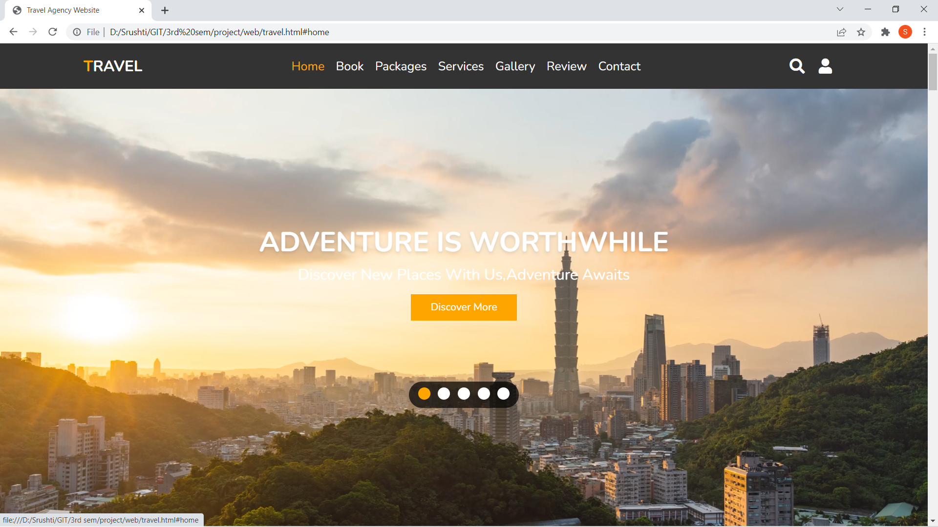

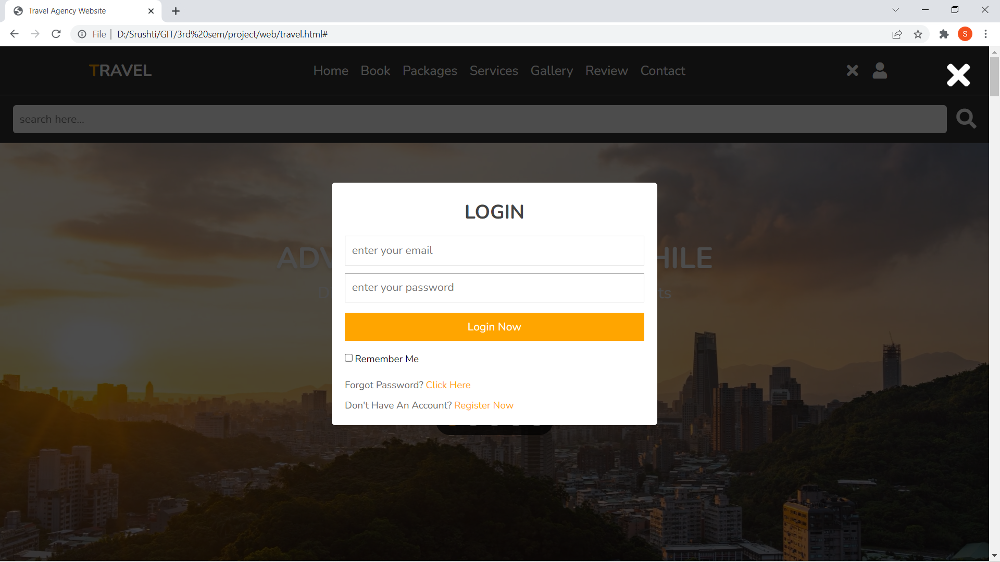

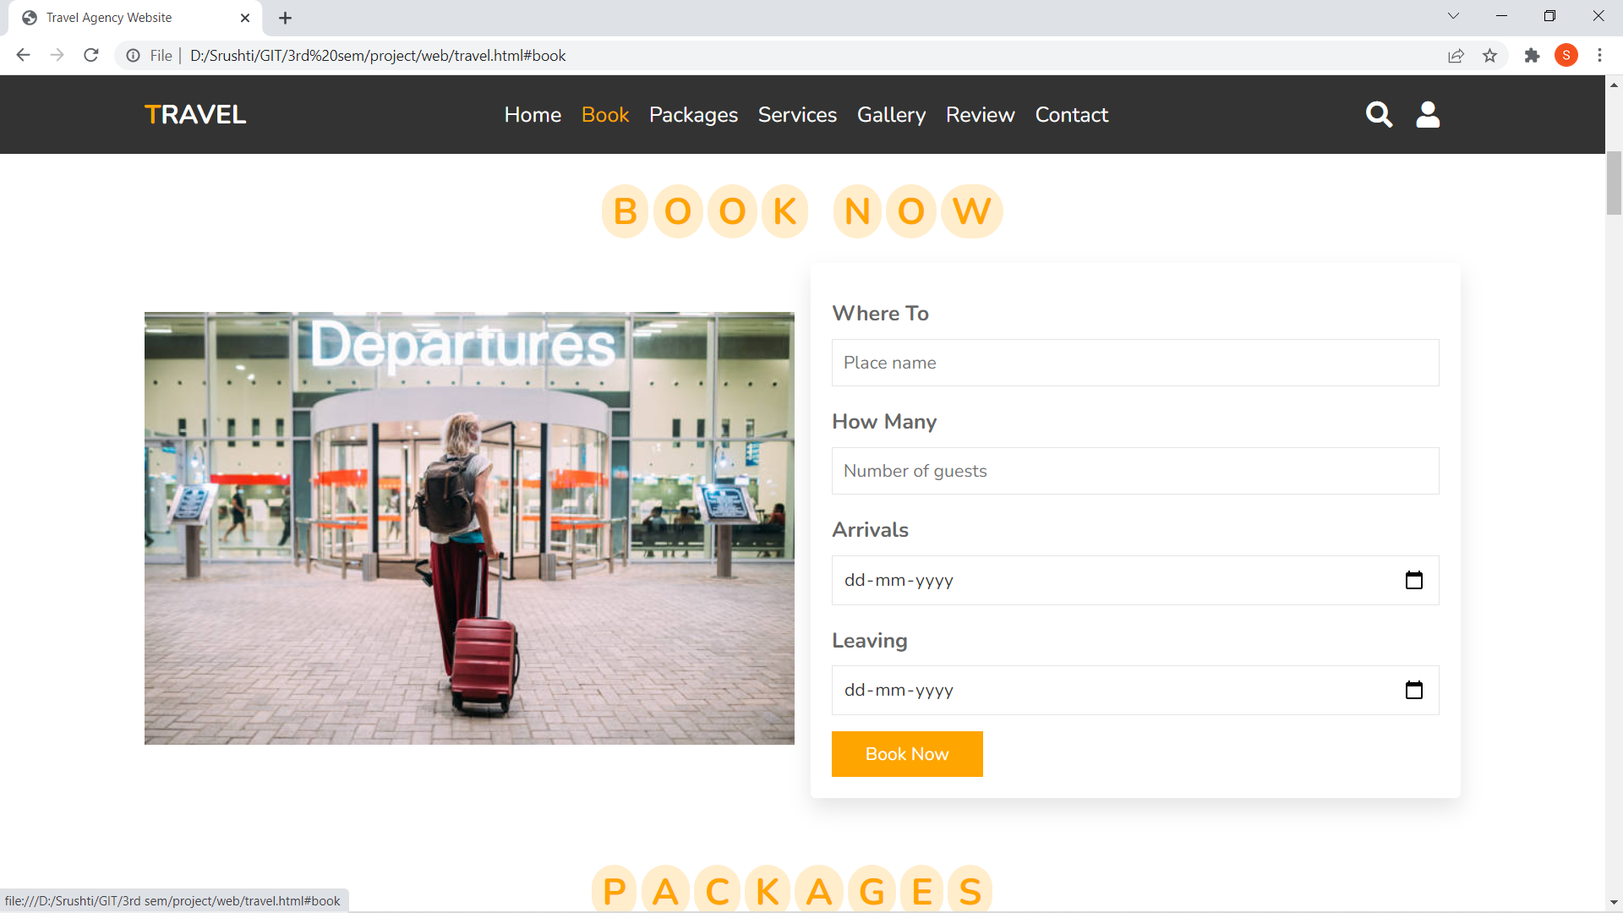

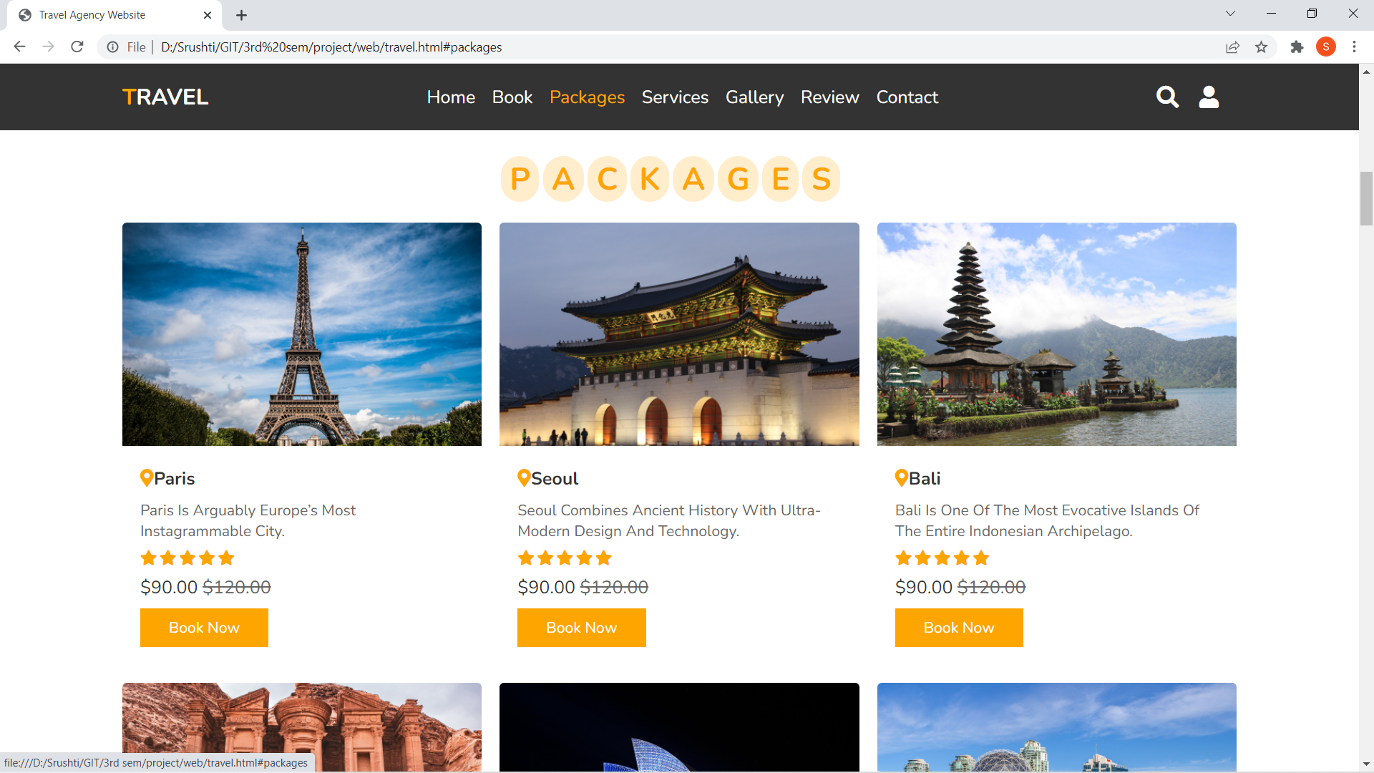

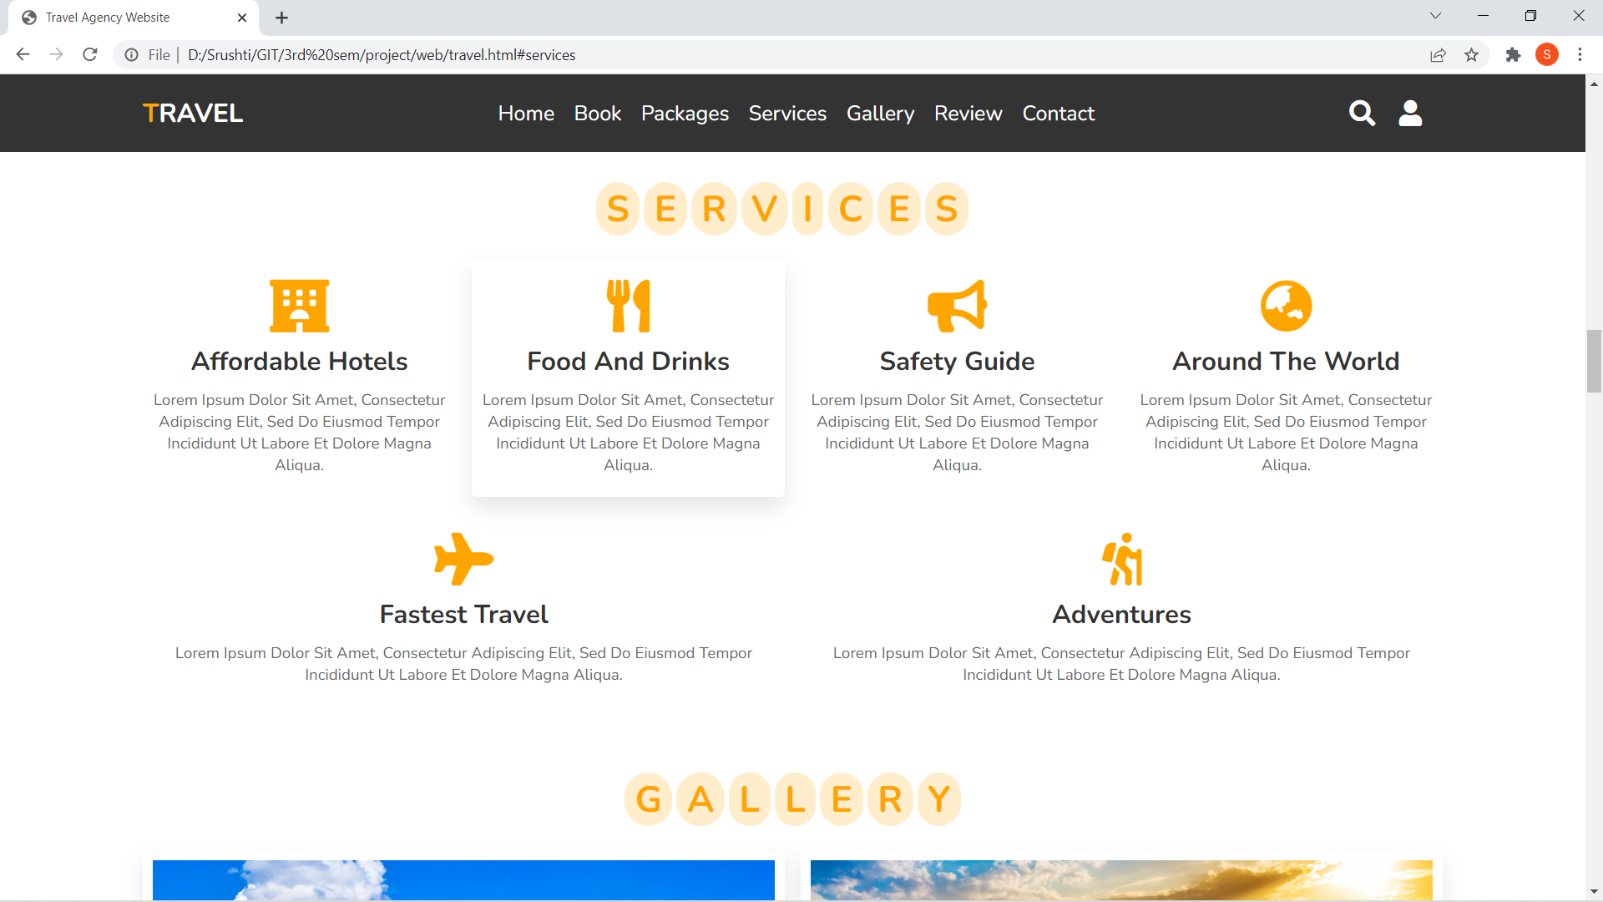

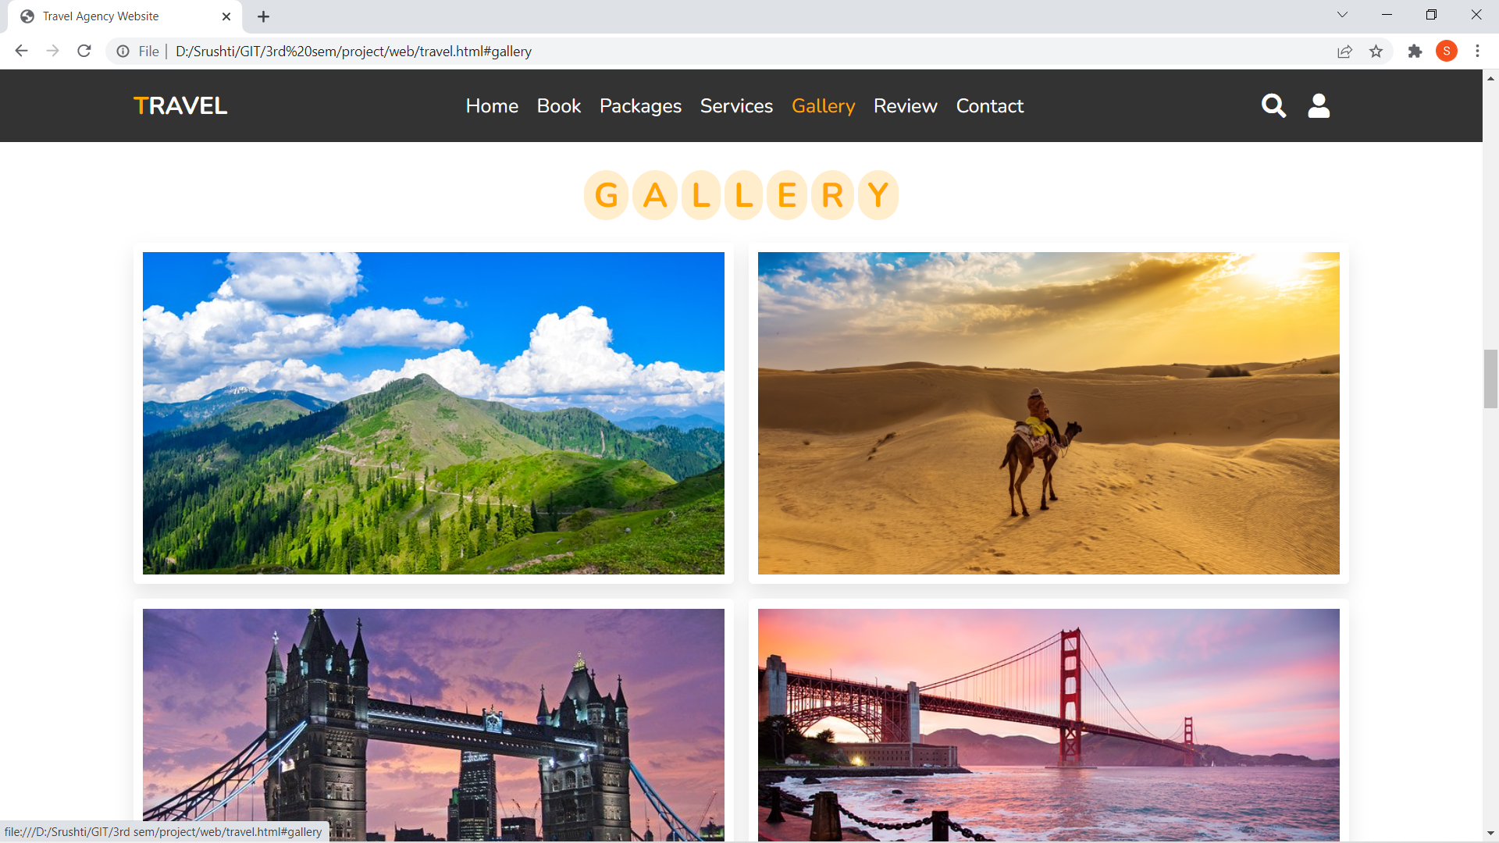

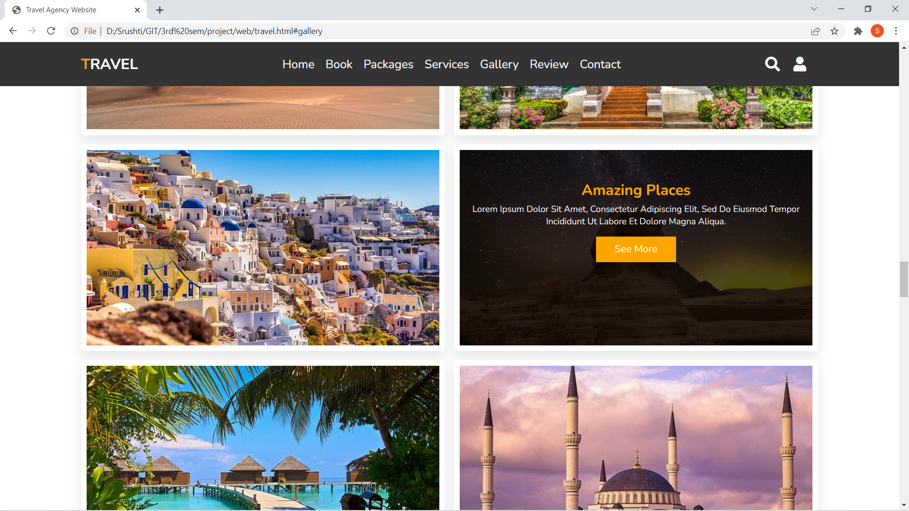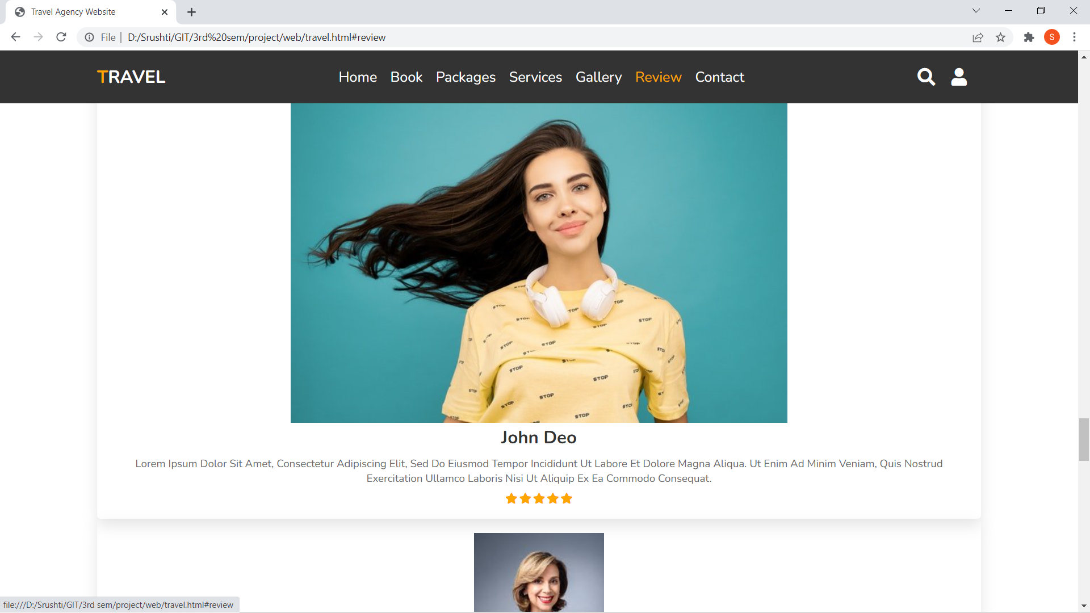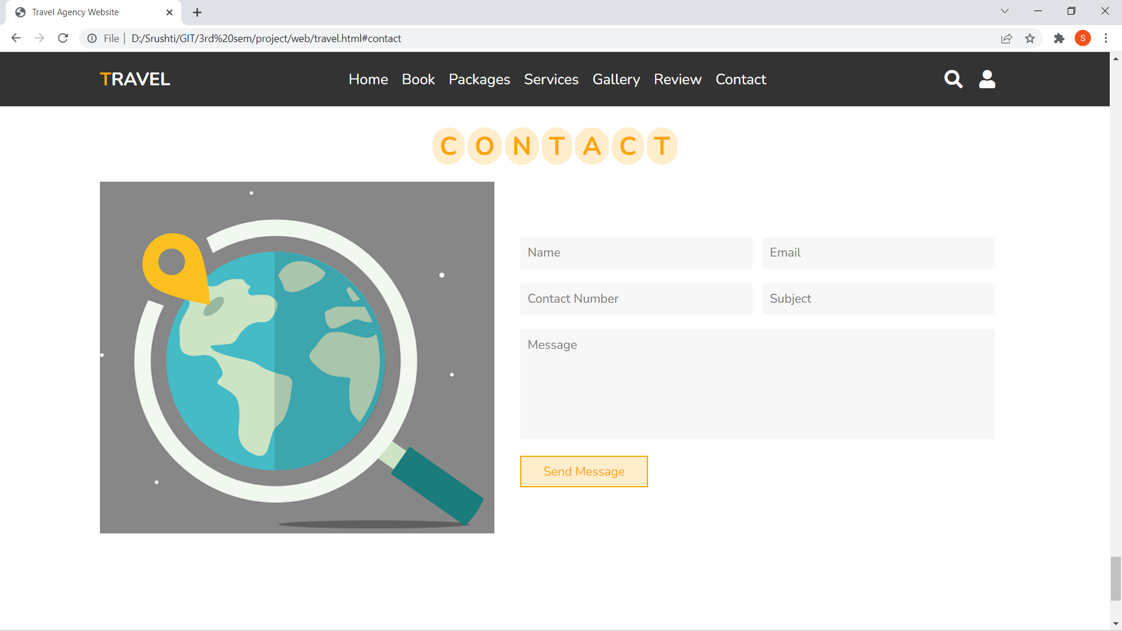

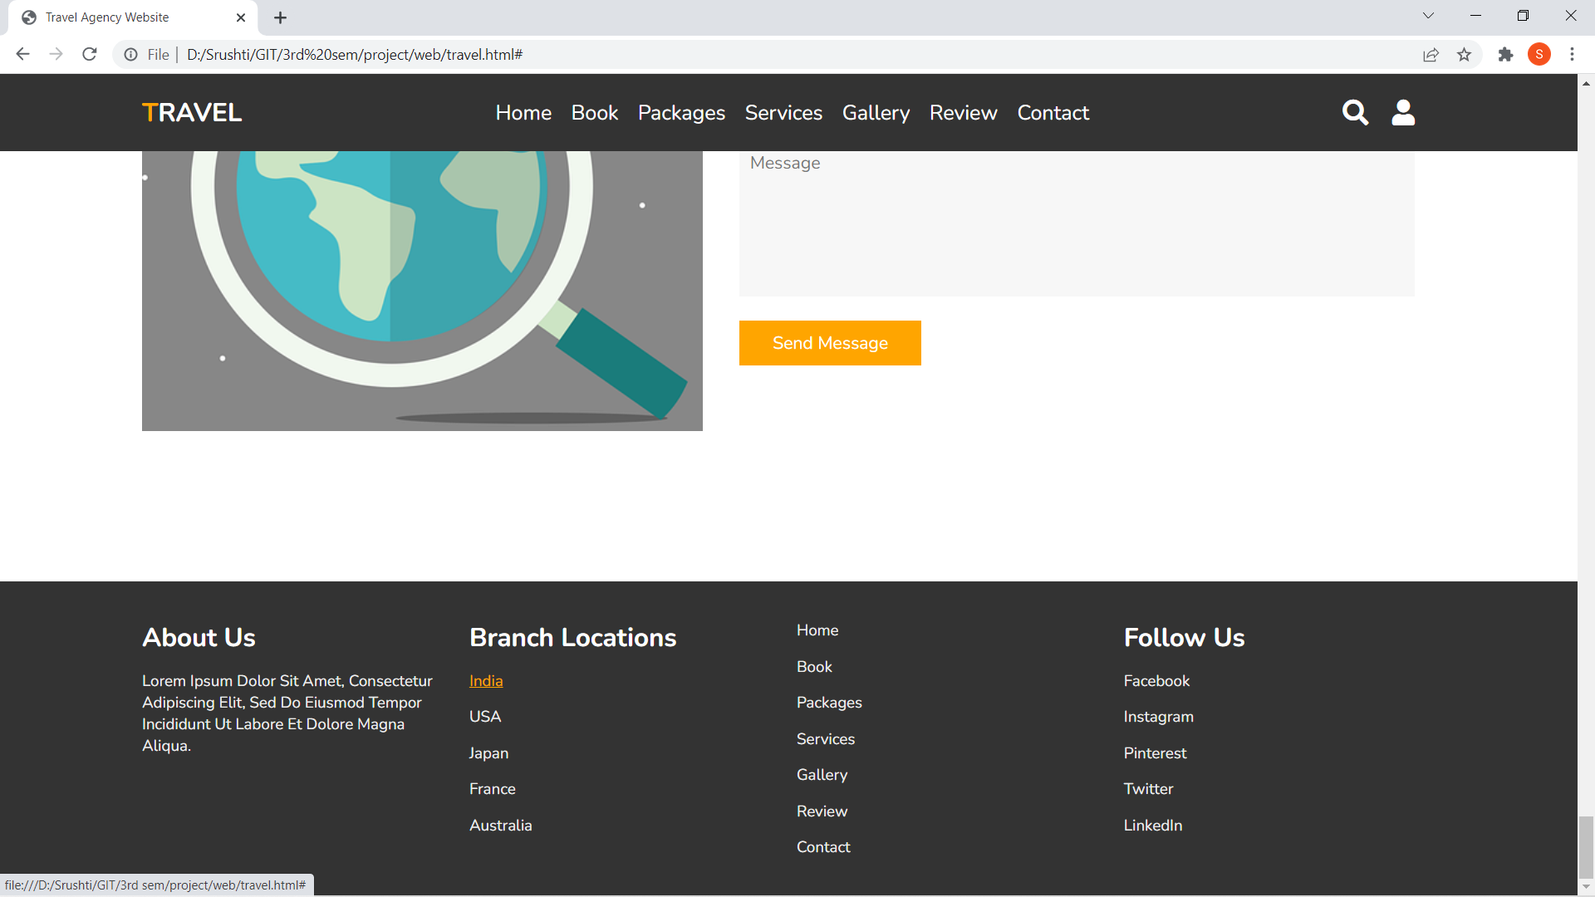

Conclusion:

We have made the project on “tours and travels website” using various programming languages like HTML, CSS and JavaScript. The project has been made as per the given specifications. We also tried to follow the holistic design principal to so that the interface of the system is simple. It also sprovides knowledge about the latest technology used in developing web enabled application and client server technology that will be great demand in future. This will provide better opportunities and guidance in future in developing projects independently

Reference:

* [**www.tutorialspoint.com**](http://www.tutorialspoint.com)
* [**www.w3schools.com**](http://www.w3schools.com)
* https://css-tricks.com